INTEGRATIVE COURSE IN PSYCHOLOGY (ICOPSYCH)

ANALYSIS ON THE RESULT OF POST-TEST EXAMINATION IN PSYCHOLOGICAL ASSESSMENT
MAY 31, 2025

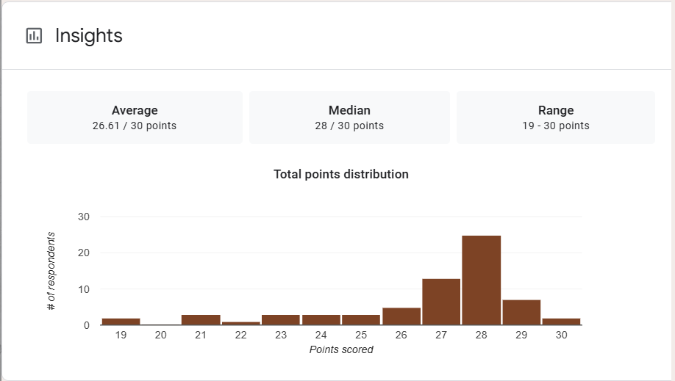

1. Mean Score: The mean score of 26.61 indicates very high average performance, equivalent to 88.7%. This suggests that the test-takers understood the material well and performed strongly overall.

2. Median Score: The median score of 28 is higher than the mean, suggesting a left-skewed distribution. A median of 28 implies that high performance was typical across the group.

3. Range: The range of 11 points (from 19 to 30) indicates limited variability. Even the lowest score (19) is about 63.3%, which shows that no participant performed poorly.

Interpretation Summary:
-The test results reflect excellent overall performance, with a high mean (26.61) and very high median (28).
-The slightly left-skewed distribution indicates that most students excelled, and only a few had modestly lower scores.
-In short, the group demonstrated uniformly strong understanding, with no significant outliers on the lower end.

RATIONALIZATION:

DIFFICULT QUESTIONS:

